 Camera controls (Mallincam) Telescope controller (NexRemote)
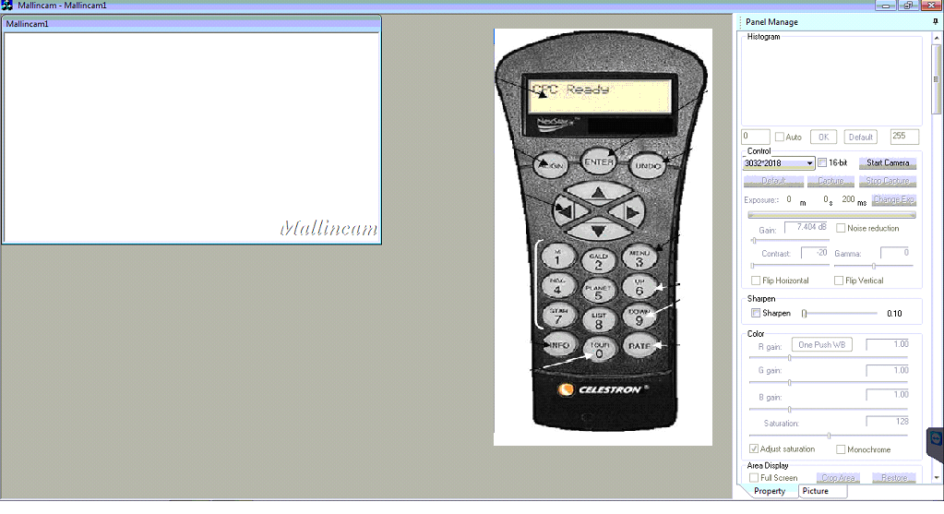

Let’s look at the moon.

- Press 5 on the remote
- Use the arrow keys to scroll through the list and select the moon
- Press ENTER
- Start the camera to see images in the preview window.
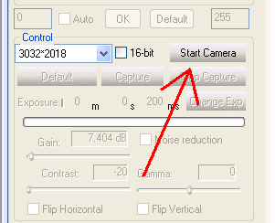
- At this point if you see the moon you can; drag and drop the remote out of the way or right click and exit the remote (minimize the mallincam to open the remote again).
- Click the CHANGE EXP button to adjust exposure length. You must set the exposure length to obtain images that show some level of detail. If the current exposure time is too short, the image will appear black or very dark. If it is too long, the image will appear washed out or white.
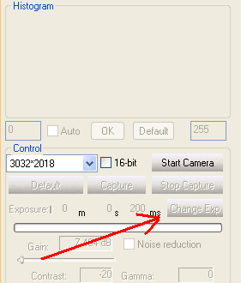
- Adjust CONTRAST to change the amount of difference between shades of colors. The bigger the number the greater the difference.
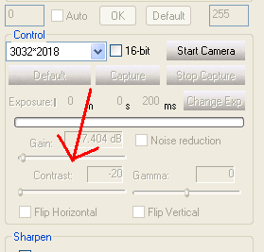

- Adjust GAMMA (light intensity) to get your desired image.
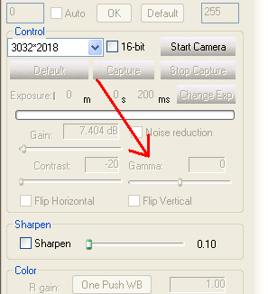

- Press CAPTURE to save an image being previewed. (If the remote is in the way do not worry, it will not show in the file when capture is pressed)
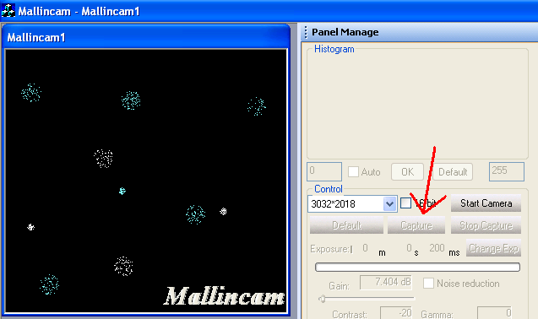

You are now ready to begin! Return to the observatory page on our website and press this icon  to download and run the Teamviewer program, once running and logged in run the Mallincam and run the NexRemote by double clicking on their icons

